

**Submitted by:**

Chaudry Ali Sher

232418

Awais Khan

232397

**ICT PROJECT PLANNING**

**Purpose:**

This portfolio's purpose is to represent my and my teammate’s work on this project. Our primary goal is to represent a bus service website which will be used by many customers, if successful and the buses will pick from a specific destination to only those who have filed the form as it will be checked every time! Our main goal is to attract workers, university students, and businessmen, who travel every day to their workspace, and universities. The buses will mostly travel on the same routes daily.

**Target audience:**

The audience we want, to grow the website are the following:

* **University students:** As many university students don’t have a car or a bike or their parents do not allow them, we want them to avail of this bus service which will help them to go by bus to their universities on a single route daily.
* **Workers:** Many workers go to their workspace or their working area daily by local buses which are very crowded and sometimes, they don’t get a seat which is very stressful, especially in summer. We want them to register and go by our buses which are vast and clean.
* **Travelers:** This bus service will also help travelers who love traveling to different places within the city. They will be provided comfortable buses that will help them to reach at their locations easily.
* **Local Residents:** People living in the area served by the bus service can use the website to access schedules, routes, and other important information.

This website will help many people within the city and our main goal is to help them reach their destination at the right time every day!

Here is the website layout for the website:

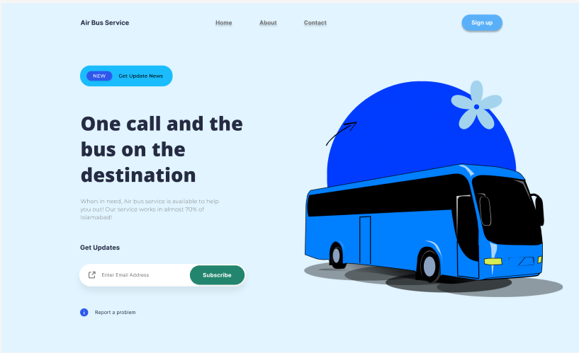

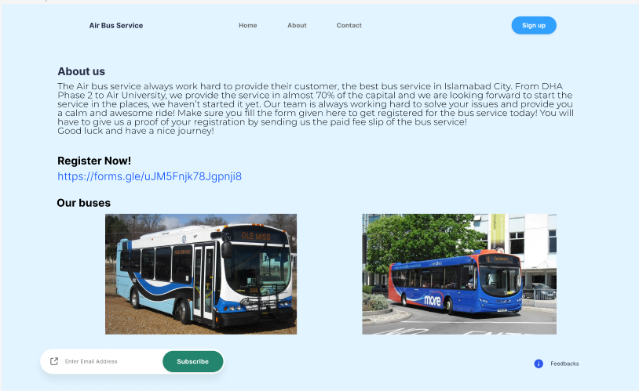

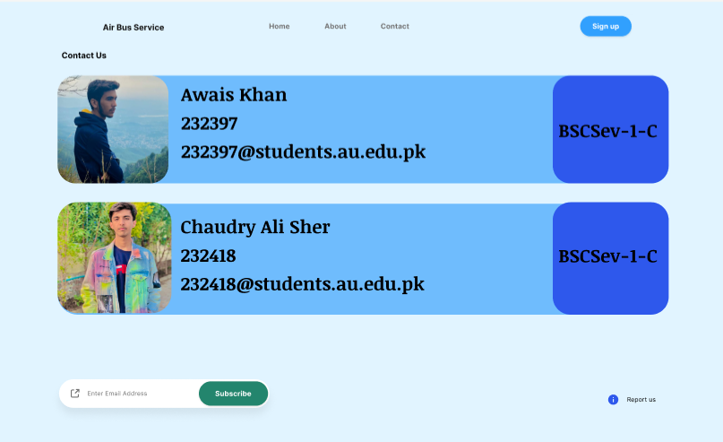

More improvements will be done when the final results come out!